INSERT INTO users(username, email, nama_lengkap)

VALUES('user1','user1@example.com','User Satu'),

('user2','user2@example.com','User Dua'),

('user3','user3@example.com','User Tiga');

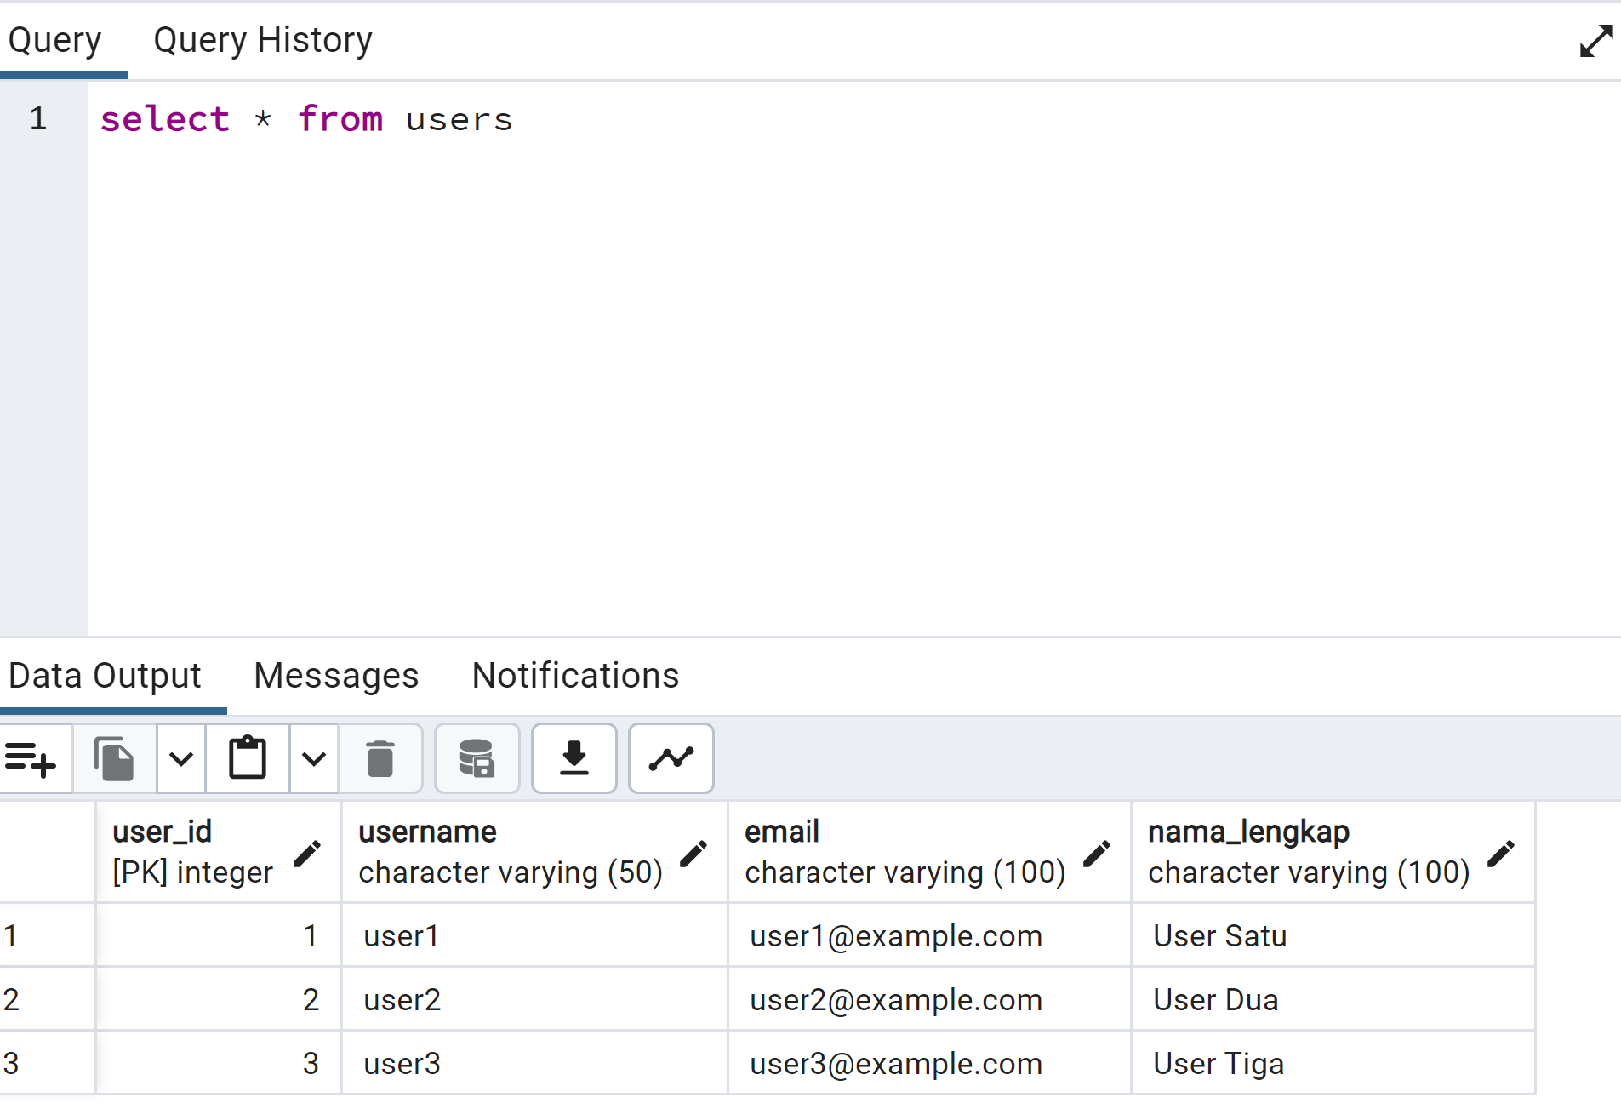

INSERT INTO orders (user_id, status) VALUES(1,'Dalam Pengiriman'),

(2,'Selesai'),

(3,'Dibatalkan');

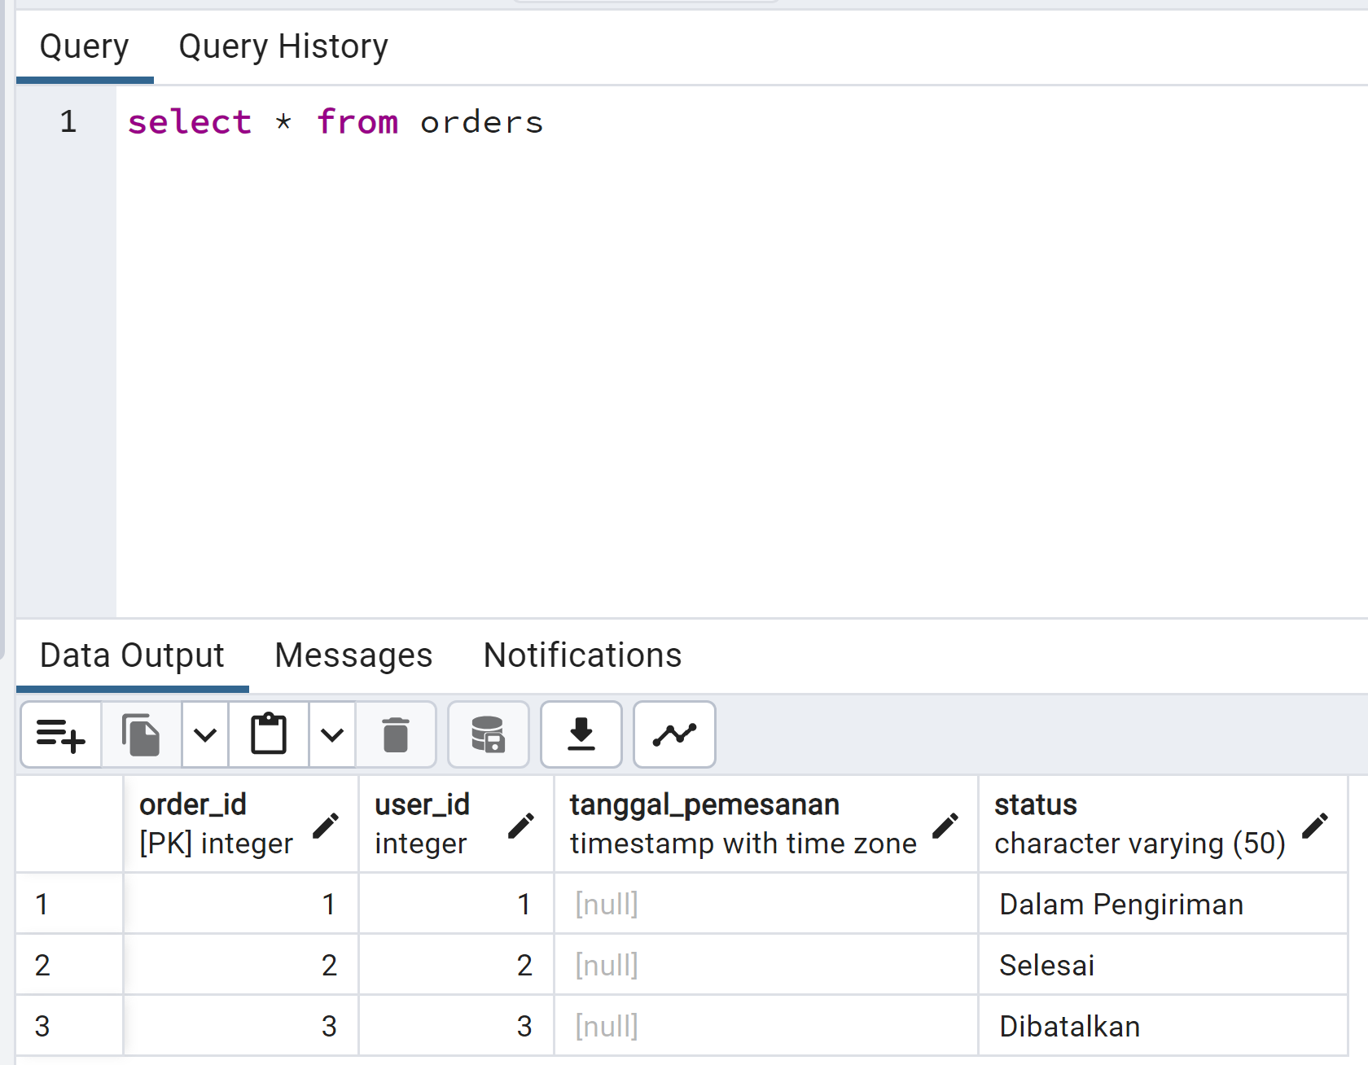

INSERT INTO order_items (order_id, product_name, quantity, harga_per_item)

VALUES(1,'Produk A',2,50000),

(1,'Produk B',3,30000),

(2,'Produk C',1,75000),

(2,'Produk D',2,60000);

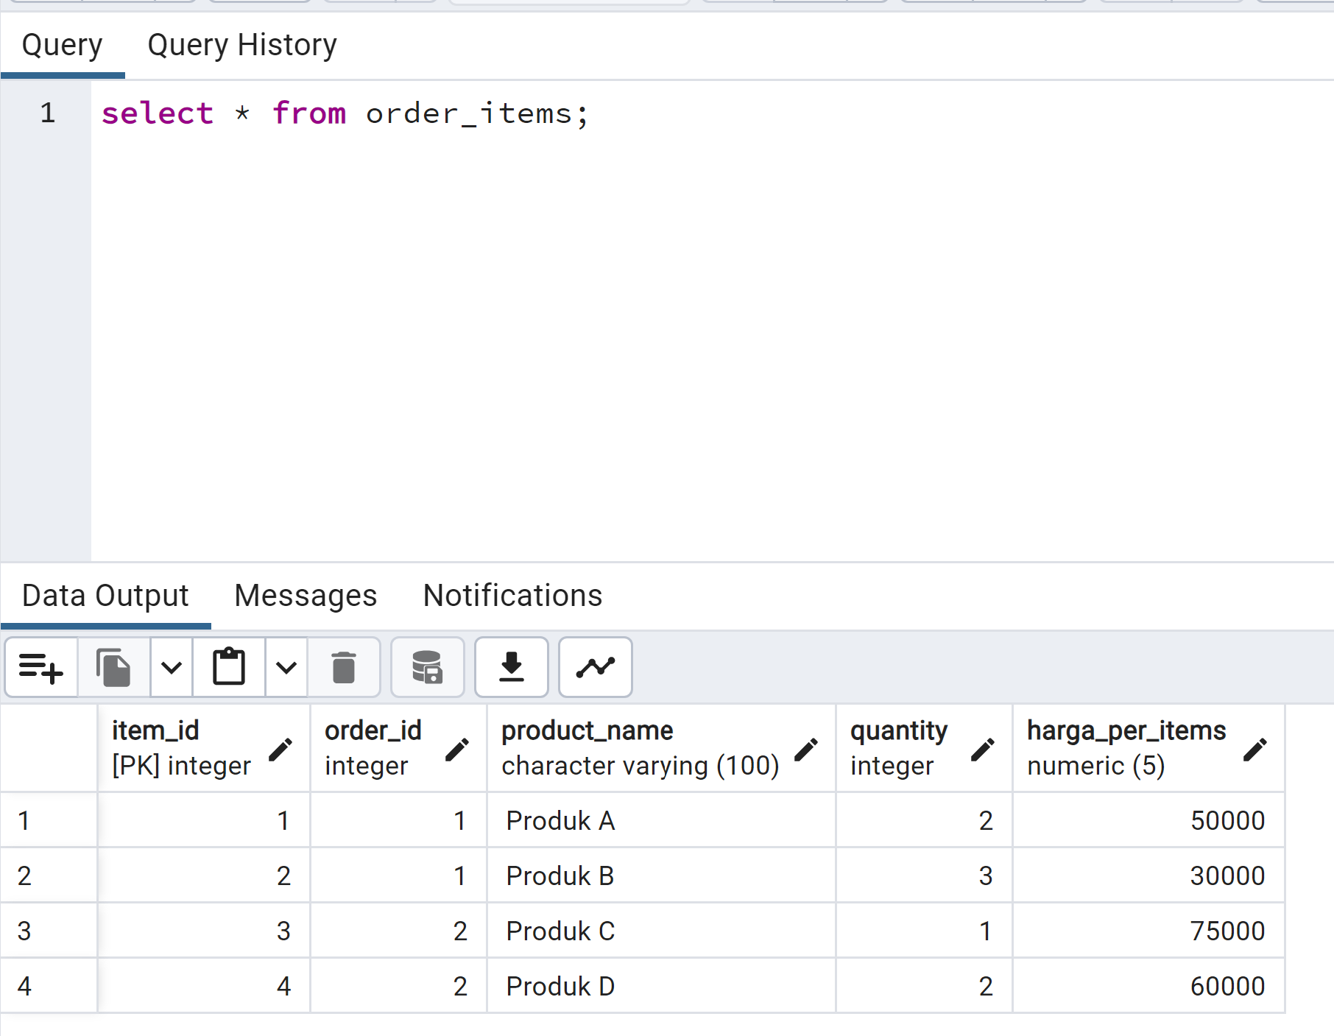

Select order_id, username from orders inner join users on users.user_id = orders.user_id;

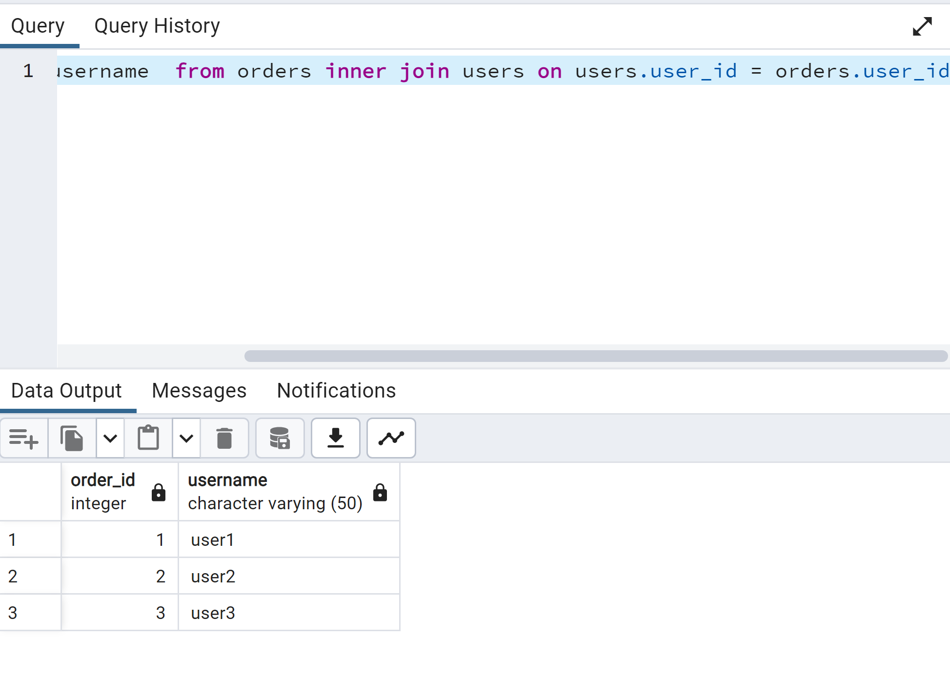

Select orders.order_id, username, sum (quantity * harga_per_items) as total_harga from orders inner join users on users.user_id = orders.user_id inner join order_items on order_items.order_id = orders.order_id group by orders.order_id, users.username;

